**System-Aided Career Advice**

Dr Prashant Kanade

Computer Department,  
Vivekanand Education.  
Society’s Institute Of,

Technology,

Mumbai, India.

[Prashant.kanade@ves.ac.in](mailto:Prashant.kanade@ves.ac.in)

Mohit Gangwani.

Computer Department,  
Vivekanand Education,

Society’s Institute Of,

Technology,  
Mumbai, India.

[2020.mohit.gangwani@ves.ac.in](mailto:2020.mohit.gangwani@ves.ac.in)

Rahul Fatnani,

Computer Department,  
Vivekanand Education,  
Society’s Institute Of,

Technology,

Mumbai, India.

[2020.rahul.fatnani@ves.ac.in](mailto:2020.rahul.fatnani@ves.ac.in)

Divya Makhija, Roshni Jaisinghani,

Computer Department, Computer Department,  
 Vivekanand Education, Vivekanand Education,

Society’s Institute Of, Society’s Institute Of,

Technology, Technology,

Mumbai, India. Mumbai, India.

[2020.divya.makhija@ves.ac.in](mailto:2020.divya.makhija@ves.ac.in) [2020.roshni.jaisinghani@ves.ac.in](mailto:2020.roshni.jaisinghani@ves.ac.in)

**ABSTRACT**

Nowadays most of the students face problems in choosing the right career. The choice of career is one of the most crucial decisions one. We have designed an Online Career Buddy System targeting students' career and future. The main aim is to make a website that helps users not only to make better choice of their career using our best given suggestion for their better future that helps students to choose the right career and to make a better choice of their career by giving various tests and by going through all the information regarding the streams .We have added different test levels which will help student be more clear about the stream he chooses .We have also added the best colleges according to the streams .We will provide the blog section in which user can view different blogs which helps student to get more information regarding various opportunities.

**Keywords**

Students,Career,Future,Choice,Tests,Information,Streams,Col-leges

# INTRODUCTION

Students must choose the correct profession to prevent problems in the future. However, many people struggle with this choice, so appropriate guidance is required. To handle this, we intend to develop software that will serve as a centralized information base. This method will provide unbiased information for students to debate and assist one another in making decisions. Assessments will also be included in the software to measure students' cognitive and reactive skills, allowing them to better rate themselves. The information repository will be divided into horizontal and vertical sections. Horizontally, it will advise students on how to prepare for various entry-level positions, and vertically, it will provide information on the long-term scope of various professions, allowing students to investigate and experiment before making a decision

# MOTIVATION

Numerous students confront challenges when attempting to choose a career path. They may need information about different career alternatives, feel questionable approximately their interface and qualities, or feel constrained to seek after a specific way due to societal or familial desires. As a result, they may battle to create an educated choice approximately their future, driving to uneasiness, hesitation, and possibly choosing a career that doesn't adjust with their interests or objectives. There are a few existing arrangements to assist students with career decision-making. These include career counseling services provided by schools, universities, and private organizations, online career assessments and personality tests, informational websites and databases about various careers, and internships or job shadowing opportunities to gain real-world experience. However, these solutions may not be accessible or affordable for all students, and the information provided may not always be unbiased or up-to-date. Our idea is to build a software which acts as a centralized knowledge-based system as students will have a common source of information, decisions will not be biased. The software will include assessments to evaluate cognitive and reactive abilities, and the knowledge base will be distributed horizontally and vertically to guide students on entry-level roles and long-term career paths. This will give students flexibility to explore and experiment before making a final decision.

# LITERATURE SURVEY

• The impact of enterprise instruction on entrepreneurial deliberate: The part of career versatility" by W. Zhou and X. Li (2021): Abstract-This paper looks for to explore the affect of enterprise instruction on entrepreneurial purposeful, with a center on the part of career adaptability.

• Factors impacting career choice and career fulfillment among nursing understudies: A precise survey" by E.L. Chia and Y.L. Lim (2021): Abstract-This paper points to recognize and look at the variables that impact career choice and career fulfillment among nursing students.

• The relationship between career versatility and career decision-making challenges among Chinese college understudies" by J. Wang et al. (2020): Abstract-This paper points to examine the relationship between career versatility and career decision-making troubles among Chinese college students.

• Career versatility and professional personality in college understudies: The interceding part of career decision-making self-efficacy" by G. Nota et al. (2020): Abstract-This paper points to look at the relationship between career versatility, professional personality, and career decision-making self-efficacy among college students.

• The affect of career instruction on career development and career decision-making self-efficacy: A metainvestigation" by R. Jaakkola and A. Nurmi (2019): Abstract-This paper looks for to survey the adequacy of career instruction mediations in progressing career development and career decision-making self- adequacy among students

# PROPOSED IDEA

The solution under consideration is a web application that intends to give pupils advice on selecting their future career. It will provide access to services including educational options, career assessments, personality and aptitude testing, and job market information. In order to select a professional route that fits with their skills, interests, and personality qualities, students are to be assisted in identifying their strengths and shortcomings

## *Block Diagram*

The paper provides a computer-based career guidance system in this part. Users are able to register and supply information that is then kept in a database. Users can take tests or receive an analysis of their skills and interests by connecting to a job guidance server through the system. The system provides the user with a career advisory result after they complete the test, assisting them in making choices about their future. Overall, this system is easy to use and offers a useful method of job counselling.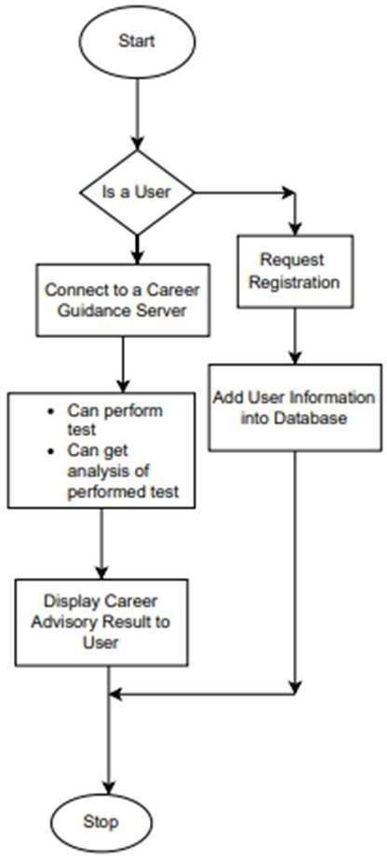

**Figure 1:Career Guidance System Block Diagram**

## *Modular Diagram*

In today's quickly advancing work advertise, it is more vital than ever to have a clear understanding of one's interests and abilities. A career direction framework can offer assistance to people make educated choices approximately their future careers. This segment of the paper examines the plan and usage of a measured chart for a career direction system.

The plan and usage of a measured graph for a career direction system are secured in this portion of the paper. The system can get or store significant data since it has got to a database. It has three components: test, student, and admin. The admin entity has the capacity to include exams, give counsel on specific careers, and recommend

careers to understudies. The test substance, which gives tests relating to different categories, permits

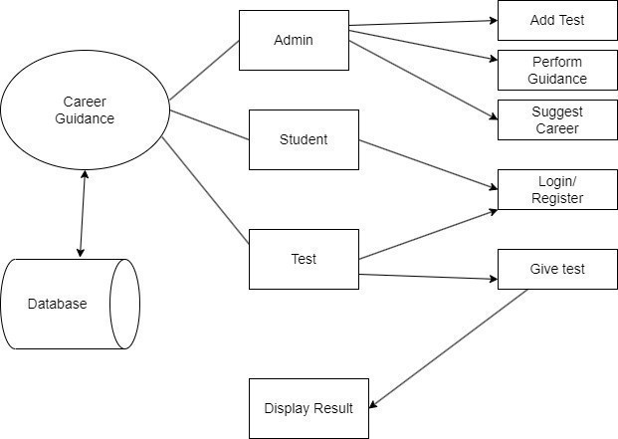

**Figure 2:Career Guidance Modular Diagram**

understudies to log in and enroll for tests. The system shows the results after the test, giving students insightful information about their abilities and interests. This modular diagram makes it simpler for people to select fulfilling jobs by presenting an efficient and approachable method for career guidance.

In order to give people insightful information about their skills and interests, career guidance is a complicated process that involves several parties working together. We will go over each component of the modular diagram of our career guidance system in this section of the research paper and how it contributes to people making wise decisions about their future careers.

1. **Career Guidance (Admin/System) :-**

The administration of the system is handled by an entity known as the admin. The admin entity has the power to add tests, provide direction for chosen careers, and make career suggestions to students. The admin entity is fundamental to making beyond any doubt the framework runs productively and gives **students** the heading they require.

1. **Database: -**

The database entity keeps track of all the relevant data regarding the students, exams, and system-provided advice. The infrastructure required for the system to operate effectively and easily is provided by the database entity.

1. **Student: -**

Students can log in and take tests using the system's student entity. Students can sign up for the tests offered by the test entity by logging in. The student entity, which offers the necessary user interface for students to engage with it, makes the system user-friendly and straightforward to navigate.

1. **Test:-**

Students take exams from the Test entity that are divided into categories like easy, medium, and hard. The examinations are designed to assess the kids' aptitudes and areas of interest and provide them with useful insight into prospective future vocations. The system depends on the test entity because it imparts to pupils the information they require to make judgements regarding their future professional lives.

1. **Add Test: -**

The admin entity can add tests to the system using the Add Test entity. In order to keep the system current with the newest tests and groups, the add test entity is essential.

1. **Perform Guidance: -**

The admin entity can give advice to students based on their interests and abilities thanks to the Perform Guidance entity. The perform guidance entity is crucial in ensuring that students receive the guidance they need to choose their future professions with knowledge.

1. **Login/Register: -**

Students can register for the system and log in to access the exams using the Login/Register entity. In order to make sure that the system is safe and that only authorized users can access it, the login/register entity is essential.

1. **Display Result: -**

The entity called "Display Result" shows the exam findings to the students both graphically and in text form (pie chart). The outcomes are based on the test-day responses given by the pupils. Students can easily interpret and comprehend the test results because of the display result entity's clear and concise representation of the results.

# CONCLUSION

In summary, a system for career guidance that incorporates aptitude testing, comprehensive information on colleges and universities, and can be a useful tool for students. Students can examine several career routes using this system, evaluate their skills and areas for growth, and make their own decisions about what they want to study and do for a living. Students who employ such a strategy can also conserve time and resources by focussing their efforts on colleges and programmes that match their interests and aptitudes. In the end, a career counselling programme can give students the resources they need to accomplish their academic and professional goals and get them started on the path to a fulfilling career.

# REFERENCES

[1] A study of the effectiveness of career guidance in high schools using a career development program" by K. Lee and K. Lee (2018)

[2] Evaluation of an online career guidance system using a randomized controlled trial" by Y. Liang, L. Li, and Y. Li (2019).

[3] Effectiveness of a career guidance program for university students in Hong Kong" by S. K. Yuen, S. C. Hui, and R. W. Y. Chan (2019).

[4] Evaluation of a career guidance program for high school students with learning disabilities" by M. C. Swerzenski, M. L. Schmitt, and M. L. Wehmeyer (2021).

[5] A randomized controlled trial of a career guidance intervention for lowincome college students" by M. J. Howell, R. L. Callahan, and B. J. Ha (2019).

[6] Effectiveness of a career guidance program for college students in Japan" by M. Ogihara and M. Nakao (2020).

[7] Career guidance for STEM students: A randomized controlled trial of a career development program" by R. L. Callahan, M. J. Howell, and K. C. Smith (2021).

[8] Evaluation of a career guidance program for high school students in China" by Y. Li and L. Li (2021).

[9] A randomized controlled trial of a career guidance program for community college students" by S. R. Rosenbaum, S. K. Mayer, and L. J. Berger (2020).

[10] Evaluation of a career guidance program for first-generation college students" by R. S. Kim, K. H. Kim, and S. Lee (2019).